9.35: The moment of inertia of the cylinder is 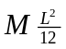 and that of each cap is 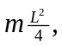 so the moment of inertia of the combination is 